Reusable Prompt Templates – Sample Prompts
1. Business Analysis Prompt Template
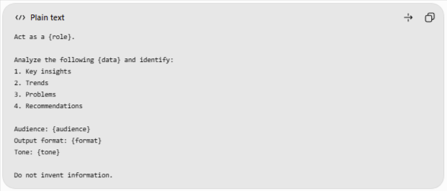
Sample prompt:
Act as a Business Analyst.
Analyze the monthly sales data and identify:
1. Key insights
2. Sales trends
3. Best-performing products
4. Three recommendations
Audience: Management
Output format: Tables and bullet points
Tone: Professional

2. Email Writing Prompt Template
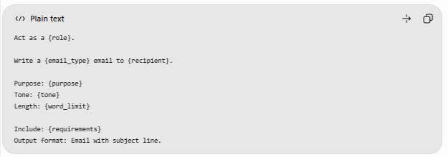
Sample prompt:
Act as a professional project coordinator.
Write a project deadline extension email to my manager.

Purpose: Request a three-day extension.
Tone: Polite and professional.
Length: Under 150 words.

Include the reason, current progress,
and requested deadline.
Output format: Email with subject line.

